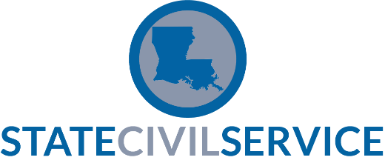 |  | SCS Performance Evaluation System – Performance Development Tool  Form Revision Date: 1/2014
NAME | POSITION |  | SUPERVISOR |  | AGENCY
Click here to enter text.
DATE DISCUSSED WITH EMPLOYEE | PROJECTED TIMEFRAME
Click here to enter a date.
The purpose of this document is to establish communication and document areas that require further performance development to reach expectations or achieve stated goals in the performance plan. This document may also reflect an agreement between supervisor and employee on the plan for development, and may also be used as supporting documentation to the overall performance evaluation to show the steps taken to enhance performance.
STEP 1: SUPERVISOR COMMENTS
DESCRIBE THE AREA OF PERFORMANCE THAT REQUIRES FURTHER DEVELOPMENT:
PROVIDE SPECIFIC EXAMPLES OR INCIDENTS (what is causing/caused the problem):
PROVIDE SUGGESTED ADJUSTMENTS THAT WILL IMPROVE/ENHANCE PERFORMANCE:
IDENTIFY TOOLS/RESOURCES THAT WILL HELP ACHIEVE THIS IMPROVEMENT (training, equipment, feedback, etc.):
STEP 2: EMPLOYEE COMMENTS
List any notable obstacles you encountered in meeting expected performance.
Do you have any questions about the expected performance or how to enhance performance?
Are there any additional goals and/or suggestions you feel will help you achieve the expected performance goal?

Employee Signature |  | Date
Supervisor’s Signature |  | Date

STEP 3: FOLLOW-UP
A follow-up discussion may occur at some point prior to the final overall evaluation so that both supervisor and employee can touch base on results of the plan. The supervisor may wish to simply document dates of discussion to signify constant communication.
Dates of follow-up discussions with employee:
STEP 4: STATUS
Follow-Up/Status Signatures:
Employee Signature |  | Date
Supervisor’s Signature |  | Date

Note: A signed copy should be provided to the employee and a copy retained for the supervisory fill to support the final overall evaluation.

